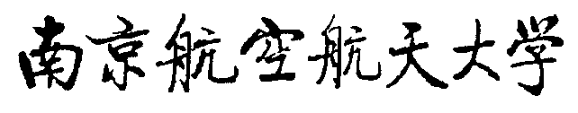
Quit Document Delivery Letter
（学生退学文件送达单）
Name |  | Class |  |  | Student No.
Major
Title of Document
Number of Quit Document |  |  |  | Date of Issue
Signature of Receiver |  |  |  | Date of Delivery
Note
PS：
1. If the quit document cannot reach to the student , please write the reason in the "Note", and put the quit document as public notice in school. After 60 days ,it will be regarded as delivered.
2. College keep this form after finishing the procedures.

