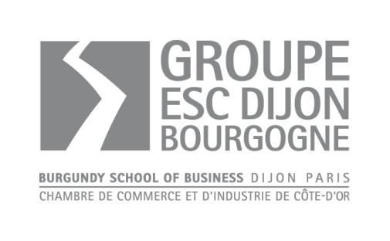

Application Form
Academic year 20…-20…

Please fill in this form in black ink and in capital letters as carefully as possible, apart from the grey parts.
This sheet and supporting documents should be sent back by:
◻ 20th May

Programme (Please tick the box):
Bachelor in Marketing and Business (2+2 Program)
English-taught programme
French-taught programme

Personnal Details
Surname:
First Name:
Gender: M F
Nationality: 2nd Nationality:
Date of birth: Place of birth:
Marital status: Single Married
Professional Status:
Permanent Address:
Postcode: City:
Country:
Home Phone Number: Cell Phone:
E-mail Address:
2nd E-mail Address:
Address where you wish to receive your mail and your admission results:

Postcode: City:
Country:
Phone Number: E-mail Address:

Academic Background

University Education
UNIVERSITY | DEGREE OBTAINED | SPECIALISATION | HONORS, RANK OR GRADE | YEAR

Secondary Education
SCHOOL | DIPLOMA | YEAR

Further Studies
Please detail:

Languages
Mother Tongue:
Language of instruction at home university (if different):
Foreign Languages: (please choose the suitable code)
1: fluent 2: very good 3: average 4: poor
LANGUAGE | READ | WRITTEN | SPOKEN
 | 1 – 2 – 3 – 4 | 1 – 2 – 3 – 4 | 1 – 2 – 3 – 4
 | 1 – 2 – 3 – 4 | 1 – 2 – 3 – 4 | 1 – 2 – 3 – 4
 | 1 – 2 – 3 – 4 | 1 – 2 – 3 – 4 | 1 – 2 – 3 – 4

Have you ever studied or travelled abroad . If yes, when and where ?

Please describe a multi-cultural experience that has particularly influenced you. Explain why.

Professional Experience/ Training Periods and Temporary Jobs

DATE | COMPANY | POSITION HELD | DESCRIPTION

Please comment on your most significant experience (work, social activities, students organisations, extra-curricular projects …)

Personal Questions
How will you be financing your studies ?

Self-Sponsored
Grant
Bank loan in your home country
Corporate sponsorship

Other:
In case of non admission, what alternative have you foreseen? Which other programmes did you apply for?

How did you hear about Burgundy School of Business ?
□ Presentation □ Education fair
Place Date
□ Ads – Posters – Press
Place
□ Embassy – Consulate – Alliance Française – Campus France
Place
□ Careers Advisors – Faculty
□ University
□ Personal contacts
□ BSBU website
□ Other

DECLARATION

I am aware of the extent of the tuition and living costs associated with studying on the programme of studies for which I am applying and I am able to meet all these expenses. I certify that the information that I have provided on this application, and on all other admission application materials, is complete, accurate and true to the best of my knowledge. I understand that misrepresentation of any information may result in cancellation of the application or registration, with no refund of any fees possible.

Date: .....................................................................Signature*: ...........................................

* If this application form was to be sent by email first, it needs to be sent by post later (original signature compulsory for legal purposes)

I hereby certify that the data in this application form is true and accurate.

Date: / /
Signature:

Please check you have enclosed the following documents
- Completed application form
- Statement of goals/objectives for studies at Burgundy School of Business
- Copy of passport/identity card, and residence permit if applicable
- Curriculum Vitae/resume in English for application to the English track or in French for application to the French track
- A certified copy of your degree (高考成绩单)
- Official academic records (courses attended + grades)
- TOEIC, TOEFL or IELTS certificate (or equivalent) required for applicants to the French and English track, excepted native English speakers
- TCF / TEF / DELF certifficate (or equivalent) for application to the French track
- Two recommendation letters
- The 5 page-essay including the references (websites, books, magazines)
Please return to: | Groupe Ecole Supérieure de Commerce de Dijon Bourgogne  International Office  29, rue Sambin  F - 21000 DIJON
What happens next?
Once we receive the completed application form and required supporting documentation, we will proceed through a four-stage selection process:
- Applicants will be requested to write an essay (approx. 10 pages) about a specific economy related issue. Applicants will be sent the thematic of the essay after reception of their application file.
- Interview with the aim of understanding candidate's motivations and career plans, and also his personality and ability to take part in activities within a multicultural group. Interview will be held in French (application to the French track) or in English (application to the English track)
- Logic reasoning test （10min）
- Final evaluation by the Admissions Committee
- Applicant confirmation: payment of a deposit by bank draft or bank transfer, prior to arrival (in case of visa refusal, the deposit will be refunded).

- All successful applicants will receive an official acceptance letter along with the Guide for International Students and information on the Induction Week that will take place prior to the start of the semester.

