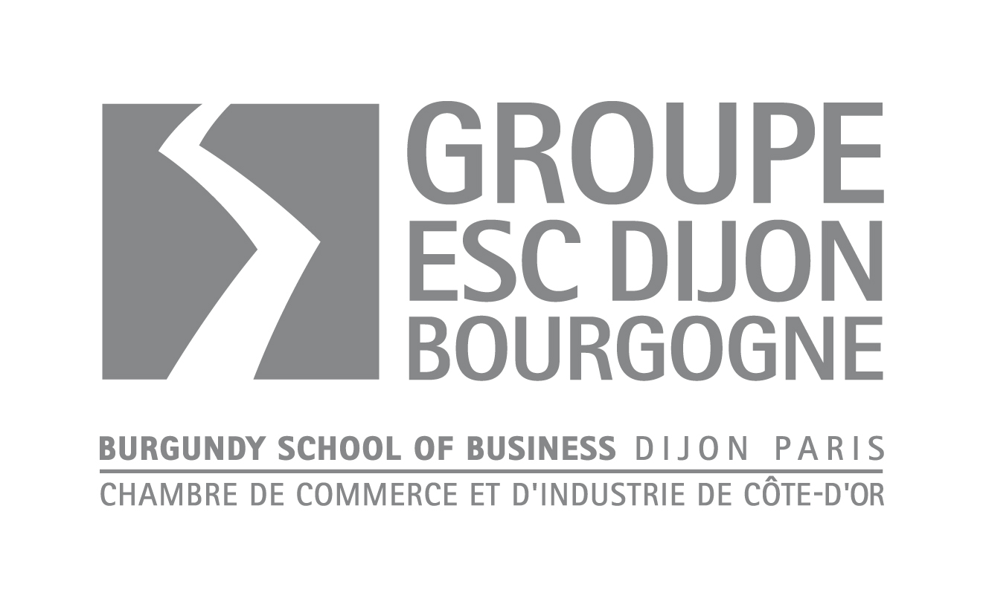
Application Form

Academic year 2011-2012

Please fill in this form in black ink and in block letters as carefully as possible.
This sheet and supporting documents must be submitted by:
◻ June 28th for visa-seeking applicants ◻ July 16th for European applicants
(not requiring a visa).

Affix
photograph
here
Programme (Please tick the box):
MSc in International Business Development (MSc IBD)
MSc in International Management (MSc IM)

Personal Details

FAMILY NAME:
FIRST NAME:
1st NATIONALITY: 2nd NATIONALITY:
Gender: M F
Date of birth: Place of birth:
Official use only:
Programme: IBD – IM – Other:
Student number:
Mode of recruitment and contacts:
Final decision:
Application received on:
Application fees:
Professional Status:
Residential Address:
Postal code (if applicable): City:
Country:
Postal Address (if different from the residential address):

Postal code (if applicable): City:
Country:
Home Phone Number: Cell Phone:
Preferred E-mail Address:
Skype ID:

Academic Background

University Education
UNIVERSITY | DEGREE OBTAINED | MAJOR  SPECIALISATION | HONORS  RANK OR GRADE | YEAR

Secondary Education
SCHOOL | DIPLOMA | YEAR

Further Studies
Please detail:

Languages
Maternal language(s):
Language of instruction at home university (if different from above):
Foreign Languages: (please indicate your level of fluency in the categories indicated)
1: fluent 2: very good 3: average 4: poor
LANGUAGE | READ | WRITTEN | SPOKEN
 | 1 – 2 – 3 – 4 | 1 – 2 – 3 – 4 | 1 – 2 – 3 – 4
 | 1 – 2 – 3 – 4 | 1 – 2 – 3 – 4 | 1 – 2 – 3 – 4
 | 1 – 2 – 3 – 4 | 1 – 2 – 3 – 4 | 1 – 2 – 3 – 4

Have you ever studied or travelled abroad . If yes, when and where ?.

Please describe a multi-cultural experience that has influenced you in particular. Explain why.

Professional Experience
DATE | COMPANY | POSITION HELD | TASKS ASSIGNED TO YOUR POSITION

Please comment on your most important life experience (work, social activities, students organisations, extra-curricular projects…) How has it had an influence on your life ?

Training Periods and Temporary Jobs
DATE | COMPANY | POSITION HELD | TASKS ASSIGNED TO YOUR POSITION

Personal Questions
If accepted, how will you be financing this programme?

Self-Sponsored
Grant
Bank Loan in your home country
Company Sponsorship

Others:
In case of non admission, what alternative have you foreseen? Which other programs have you applied (or do you intend to apply) for?

How did you hear about Burgundy School of Business ?
□ Presentation □ Career Days
Place Date
□ Ads – Posters – Press
Place
□ Embassy – Consulate – Alliance Française
Place
□ Careers Advisors – Faculty : ………………………………………………………………………………….
□ University
□ Company Internship
□ Personal contacts
□ BSBU website
□ Other

Application FeeS: € 100

Payment to be included with the application form.
Please indicate which method of payment you have chosen
- I will pay the application fees of € 100 by including a cheque, payable to "Groupe ESC Dijon"
- I will pay the application fees of € 100 by bank transfer in Euros to the following account:

Name and address of the bank: LE CREDIT LYONNAIS
18 rue de la République
69002 LYON
Account Holder: CCI Côte d'Or / Groupe ESC Dijon Bourgogne
BP 50608
21006 DIJON Cedex

BIC/SWIFT: CRLYFRPP
IBAN: FR08 3000 2025 5500 0006 0265 F43

APPLICATION PROCEDURE:

- Registration form is submitted to the admission office for review

- Interview with the applicant

- Final decision

- Applicant confirmation: payment of a deposit by bank draft or bank transfer, prior to arrival (in case of visa refusal, the deposit will be refunded).

- Issuance of the final letter of acceptance

DECLARATION

I am aware of the extent of the tuition and living costs associated with studying on the programme of studies for which I am applying and I am able to meet all these expenses. I certify that the information that I have provided on this application, and on all other admission application materials, is complete, accurate and true to the best of my knowledge. I understand that misrepresentation of any information may result in cancellation of the application or registration, with no refund of any fees possible.

Date: .....................................................................Signature*: ...........................................

* If this application form was to be sent by email first, it needs to be sent by post later (original signature compulsory for legal acceptance)

Please check you have enclosed the following documents:
- Completed application form
- Statement of goals/objectives for studies at Burgundy School of Business
- Copy of passport/identity card, and residence permit if applicable
- Curriculum Vitae/resume
- A certified copy of your degree translated into French or English
- Official academic records (courses attended + grades)
- TOEIC or TOEFL certificate (or equivalent) for non English native speakers
- One professional and one personal letter of recommandation
- Payment method for application fee of € 100
Please return to: | Groupe Ecole Supérieure de Commerce de Dijon Bourgogne  Postgraduate Programmes  29, rue Sambin  F - 21000 DIJON  Evelyne FONTERAY, MSc Programmes Assistant  Telephone: +33 380 72 59 16  Fax: +33 380 72 58 65  e-mail evelyne.fonteray@escdijon.eu  website: www.bsbu.eu

