**Certification for Suspension (for college)**

**休学证明书存单**

|  |  |  |  |  |  |
| --- | --- | --- | --- | --- | --- |
| Name |  | Class |  | Student No. |  |
| Address |  | | | | |
| Suspension Reason |  | | | | |
| Duration | Since Year Month to Year Month | | | | |

Year Month Day

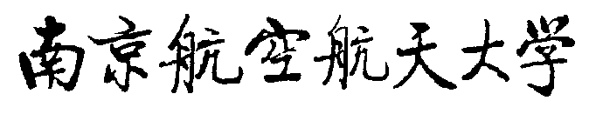

**Certification for Suspension(休学证明书)**

This is to certify that (name),from _______________(college),________________(class),has been approved to suspending schooling from (year) (month) to ______(year)_______(month). Student should hold this certification and come back to school to do restart procedures when the duration of suspension finishes. If student do not come back on time, student will be disqualified. Year Month Day