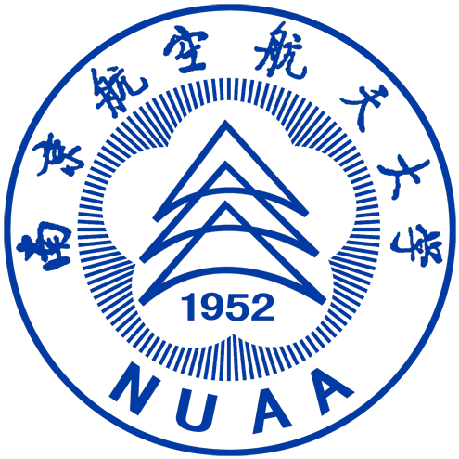 | 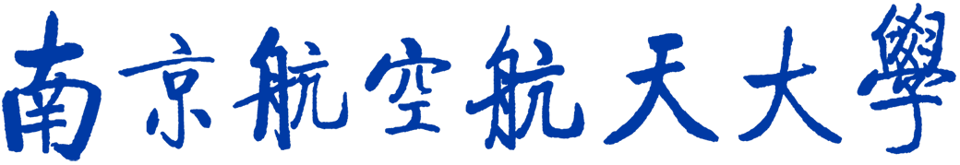  Nanjing University of Aeronautics and Astronautics

